Peak Power and Body Mass as Predictors of Bone Strength in Healthy Male and Female Adults |  | Received: 11 August 2021  Supplementary materials: https://osf.io/krpx4  For correspondence:  vanessa.yingling@csueastbay.edu
Andrew T. Denys, Jastine C. Bugayong, Candace C. Juhala, Eric J. Ma, Katelyn E. Carvalho, Sarah M. Kwong, Vanessa R. Yingling
Department of Kinesiology, California State University East Bay, 25800 Carlos Bee Boulevard, Hayward, Ca 94542
Please cite as: Denys, A. T.; Bugayong, J. C.; Juhala, C. C.; Ma, E. J.; Carvalho, K. E.; Kwong, S. M.; Yingling, V. R. Predictors of Bone Strength in Healthy Male and Female Adults. SportRxiv. https://doi.org/10.51224/SRXIV.1.

ABSTRACT
Objective: The purpose of this study was to examine whether a common, non-invasive, muscular fitness field test was a better predictor of bone strength compared to body mass in healthy adults. .
Methods: Hierarchical multiple regression analyses were used to determine the amount of variance that peak power explained for bone strength of the tibia compared to body mass. Peak power was estimated from maximal vertical jump height using the Sayer’s equation. Peripheral quantitative computed tomography scans were used to assess bone strength measures. Results: Peak power (ꞵ=0.541, p<0.001) contributed more to the unique variance in bone strength index for compression compared to body mass (ꞵ=-0.102, p=0.332). For polar strength strain index, the beta coefficient for body mass remained significant (ꞵ=0.257, p<0.006), however peak power’s contribution was similar (ꞵ=0.213, p= 0.051). Conclusion: Compared to body mass, peak power was a better predictor for trabecular bone strength but similar to body mass for cortical bone strength. These data provide additional support for the development of a vertical jump test as a simple, objective, valid and reliable measure to monitor bone strength among youth and adult populations.

Introduction
Osteoporosis and sarcopenia are musculoskeletal conditions which collectively increase the risk of bone fractures in aging adults ^{1–3}. Osteoporosis has become a serious threat to global public health as an underlying cause of more than 8.9 million fractures annually, and is accompanied by high morbidity and mortality rates ^{4–6}. Evidence suggests that sarcopenia, the decrease in muscle mass and mechanical function, is associated with a 2-fold increase in fall risk and a 3.7-fold increase in mortality ^{7,8}. An increasing number of at-risk elderly is an anticipated concern when the world’s population aged 60 and over is expected to increase from 1 billion in 2017 to 2.1 billion by 2050. ⁹

There is no known cure for osteoporosis, only preventative care designed to optimize and maintain muscle function and bone strength in order to reduce osteoporotic fracture risk. Physical activity is a significant component of osteoporosis prevention through mechanisms of bone-strength accrual as described by Frost’s mechanostat theory ¹⁰. Investigations of bilateral differences in bone strength among racket sport athletes reported higher bone strength in their racket arm ^{11,12}. In the UK, positive associations between steps per day and bone strength in a 62-year old cohort (male and female) were reported; demonstrating the importance of habitual physical activity and associated loading effects on the skeleton ¹³. Longitudinal studies among children and adolescents, demonstrated positive associations between moderate to vigorous physical activity and bone strength ¹⁴. Bilateral differences were also observed among baseball players, where benefits to bone strength acquired during youth persisted throughout life, even after the athletes returned to habitual levels of loading ¹⁵. However, there are currently no tools for monitoring bone health for prevention and screening purposes in healthy adults or youth. The current clinical diagnostic tool for osteoporosis is dual x-ray absorptiometry (DXA) scanning, and it is primarily used on older women.

Physical fitness field testing assesses skill-related components of physical activity and may also provide a means to assess bone strength. During physical activity, weight-bearing and muscular forces are the primary loads placed upon the skeletal system. The loading effect of weight-bearing forces on the skeletal system may be largely dependent upon body mass. However, in a sample of postmenopausal women with high BMI, evidence indicated an increase in bone strength was not proportionate with total fat or total body mass; the effect was proportional only to total lean mass ¹⁶. The same report separated the sample into sedentary and active groups; the exercising women had significantly higher strength of correlation between lean body mass and bone mineral density ¹⁶. Lean mass and its force-generating capacity are key to bone strength optimization. Muscle generated forces have a greater magnitude of loading on the skeletal system due to their mechanical disadvantage. Short moment arms require muscles to produce high forces to generate joint torque for movement, and multiple studies demonstrated strong correlations between muscular fitness and bone strength indices in many populations ^{17–20}.

Rantalainen reported that body mass was not an independent predictor of bone strength compared to a muscle fitness test, concentric net impulse measured via maximal vertical jump testing on a force-plate, in athletic premenopausal women and osteoarthritic postmenopausal women ³. The purpose of the present study was to examine whether a common, non-invasive, muscular fitness field test was a better predictor of bone strength compared to body mass in healthy male and female adults.. We hypothesized that peak vertical jump power at take-off would be a significant and greater contributor of the explained variance for bone strength (BSIc and SSIp) compared to body mass.

Materials and Methods
Recruitment and Participant Characteristics:
A convenience sample of 142 participants (79 F, 63 M) (13.3% African American/Black, 17.9% Latina/o, 28.6% White, 27.6% Asian/Pacific Islander, 1.0% American Indian or Alaskan Native and 11.7% Mixed Race or Unknown) was recruited for this observational, cross-sectional study, from the faculty, staff, and students at a mid-sized regional university. Participants were recruited through flyers, emails to the university community, and word of mouth advertisement. Participants received no compensation for participation. A general health and demographic survey was completed by all participants prior to the start of data collection to determine age, sex, and ethnicity of the participants. Participants were excluded if they had a history of any diseases that might influence bone health (endocrine diseases, gastrointestinal disorders, and eating disorders), were under 18 years of age, smoked or were pregnant. All participants were informed of the risks and benefits of the study and provided written informed consent. The study was approved by the California State University, East Bay Institutional Review Board (IRB) (CSUEB-IRB-2016-223-F). The study was pre-registered at the Center for Open Science OSF (https://osf.io/krpx4- DOI 10.17605/OSF.IO/B5QZC).

Anthropometric Measures:
Body mass and body fat percentage were measured using the Bod Pod (BOD POD ® 2007A; Cosmed USA Inc, Concord, CA). Participants were instructed to refrain from exercising and food or drink consumption 3 to 5 hours prior to testing to ensure accurate and repeatable measurements. Participants’ standing height was measured in meters using a stadiometer (Seca, Chino, CA) to the nearest 0.1 cm.

Bone Strength Assessment by pQCT:
Peripheral quantitative computed tomography (pQCT) (XCT 2000 Stratec Medizintechnik, Pforzheim, Germany) scans were used to assess bone strength measures of the dominant tibia. Tibial dominance was determined by asking participants, “Which hand do you write with?” with the assumption that dominance was ipsilateral. Two measurements of tibial length from the medial epicondyle to the medial malleolus were taken and averaged. For all participants, a 30 mm planar scout scan was performed to locate the distal end of the tibia representing the 0 position in order to determine the 4% and 50% sites of the tibial length, after which the two sites were scanned. The voxel size was set to 0.5 mm, slice thickness was 2 mm and the scanning speed was 30 mm/s. Slice images were analyzed using the manufacturer’s software (version 6.20). Regions of Interest (ROI) were identified using auto find and minimize functions of the 2000L software package, manual corrections were made using a visual check as necessary. For the 4% tibial site, bone strength index in compression (BSIc) and other trabecular bone parameters were calculated using contour mode 3, peel mode 4, and a threshold of 169 mg/cm³. At the 50% tibial site, strength-strain index polar (SSIp) and polar moment of inertia (MoI), contour mode 1, peel mode 2, and a threshold of 480 mm/cm³ were used. The remaining cortical bone parameters were calculated using contour mode 1, peel mode 2, and a threshold of 710 mg/cm³.
Bone strength is developed through a combination of the size and geometry (architecture) changes within a bone as well as bone’s material properties (bone mineral density). Trabecular bone outcome measures included measures of bone size, total bone mineral content (vBMC.tb (mg/mm)), and geometry measured by total area (ToA.tb (mm²)) as well as volumetric bone mineral density (vBMD.tb (mg/cm³)). For the 4% tibial site, BSIc is a combination of both density and architecture (formula below) ²¹.
BSIc = ToD² (mg/cm³ /1000) * ToA.tb (mm²) ¹²
ToD: total density
ToA.tb: total area
Cortical bone measures included bone mineral density (cBMD (mg/cm³)), a material property. Bone size was measured using cortical area (CoA (mm²)) and bone architecture using total area (ToA (mm²)) and MOI. A composite strength measurement, SSIp (mm³), combined the material property (cBMD) with the architecture measure, MoI (formula below) ²².
SSIp = (MoI/ D max) * (cBMD/ND) ²²
MoI: Polar Moment of Inertia
D max = maximum distance of a voxel from the center of gravity
cBMD = measured cortical density (mg/cm³) mineral per unit of cortical bone volume
ND = normal physiological density (1200 mg/cm³)

All scans were acquired and analyzed by 1 of 2 technicians holding Limited Permit X-Ray Technician certifications from the California Department of Public Health. The short-term in vivo precision (root-mean-square (RMS) -CV %) ²³ in our laboratory for tibial scans has been estimated between 0.5704% and 0.8957%. All scans were checked for movement artifacts at the time of the initial scan by a technician. Manufacturer supplied hydroxyapatite phantoms for pQCT were scanned daily prior to data collection.

Vertical Jump Test:
Maximal jump height was measured using a Vertec™ (JUMPUSA.com, Sunnyvale, CA). Participants completed a warm-up and two practice jumps prior to testing. The participant's standing reach was measured and three maximal countermovement vertical jumps (CMJ) were performed to displace the Vertec™ vanes with a 20-second rest between jumps. Maximal jump height was calculated as the difference between the jump height and the standing reach height. Peak vertical jump power at take-off was calculated from the maximal jump height using the Sayer’s equation below:
Peak Vertical Jump Power (W) = [51.9 * CMJ height (cm)] + [48.9 * Body mass (kg)] - 2007 ²⁴
Reliability of the above vertical jump height protocol was determined using 10 participants (Age 24.6 yr (3.0 yr); 5 female) who performed 3 maximal countermovement vertical jumps during 2 sessions that were 7 days apart. Maximal vertical jump height was then averaged for the 3 trials for each session and a Pearson correlation was run to determine reliability. The correlation coefficient for the test-re-test of the vertical jump was r=0.99 95% CI (0.96-0.99). ²⁰

Statistical Analysis:
A prior sample size estimation of 67 participants was calculated using GPower 3.1 software ²⁵ assuming a medium effect size (0.15) and a power of 0.8 at the standard 0.05 alpha error probability. Two datasets were combined for this analysis. Methods were similar for both datasets, but one was collected on university athletes ²⁶ and the other on the general healthy university population (not published). A one-way ANOVA indicated no effect of athlete status (F (1,142)=0.247, p=0.620, partial $η2$=0.002). Preliminary analyses were performed to ensure there was not a violation of the assumption of normality for the dependent variable, PP, including tests for skewness and kurtosis, Shapiro-Wilks test, and assessment of the Q-Q plots. Outliers were assessed using standardized variables and no data was excluded. The total number of participants used for each analysis are reported in the text and on the tables. Independent unpaired t-test was used to determine differences between genders. All statistical analyses were performed with SPSS 27.0 software (SPSS Inc, Chicago, Illinois) with an alpha level of 0.05. To test the hypothesis that peak power (calculated from the Sayer’s equation) would be a significant and greater contributor of the explained variance for bone strength (BSIc and SSIp) compared to body mass, a hierarchical multiple regression (HMR) analysis was used. HMR determined the amount of variance that peak power (predictor or independent variable) explained for bone strength parameters in both the cortical and trabecular regions of the tibia compared to a base model that included body mass. Two steps were used for these analyses of the dependent variables (BSIc and SSIp). In the first step, predictor variables age, height, body mass, and sex were entered into the model, while peak power was entered in the second step.

Results
The use of the term “peak power” refers to peak vertical jump power at take-off calculated from the maximal jump height using the Sayer’s equation. Descriptive statistics display differences between male and female participants (Table 1). As expected, independent t-test revealed means were significantly different (p<0.001) between males and females for all characteristics, except age (p = 0.0827). Male participants were taller, heavier and had greater compressive (BSIc) and torsional (SSIp) bone strength (Table 1). The average body mass (kg) for the male group was 73.8 (10.7), whereas the females’ average was 64.1 (11.2) . The peak power (Watts) average for the male group was 4507.5 (980.3) and the female group had an average of 3219.4 (803.3) (Table 1).

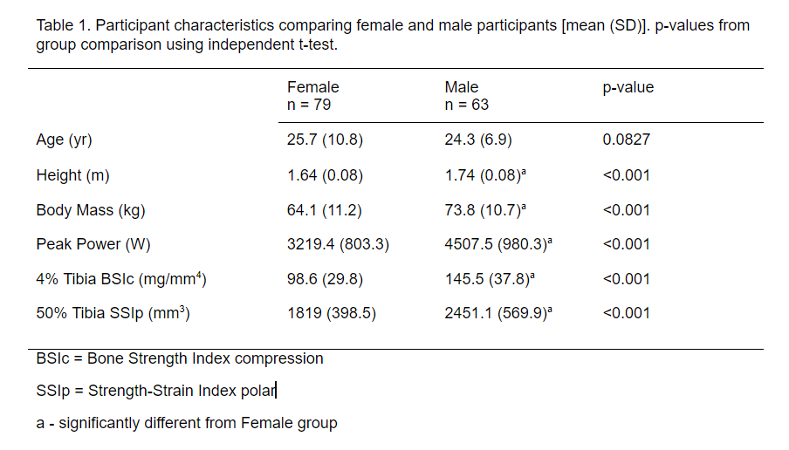

Positive associations were found between bone strength, body mass and peak power in both the trabecular and cortical bone regions (Table 2). The correlation coefficient between body mass and compressive strength index (BSIc) was 0.435, and 0.658 between body mass and torsional strength index (SSIp). However, the correlation coefficient between BSIc and peak power was 48% greater than that between BSIc and body mass (Table 2). An 8% stronger correlation was found between SSIp and peak power compared to SSIp and body mass (Table 2).

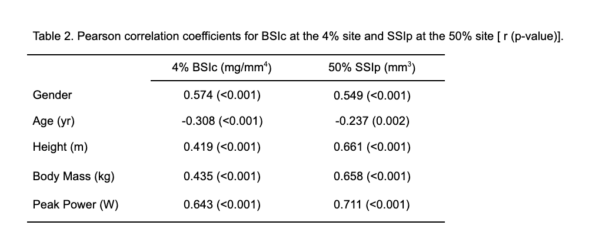

For BSIc, model 1 explained 43.7% of the variance and the addition of peak power increased the explained variance to 50.9% (p < 0.001) an increase in explanatory power of 7.2% (Table 3). For SSIp, model 1 had an R² of 0.599, and model 2 had a R² value of 0.610, an increase in explained variance of 1.1% (p > 0.001) (Table 3).

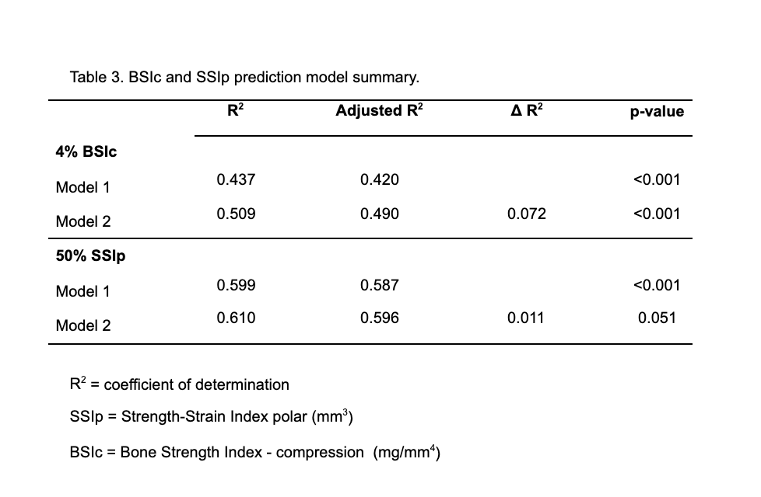

The influence of body mass decreased from model 1 to model 2. Based on the standardized beta coefficients, body mass explained 22.6% (p = 0.005) of the variance for the compressive strength index (BSIc) and 38.6% (p < 0.001) of the variance for the torsional strength index (SSIp) (Table 4). Peak power (0.541, p<0.001) contributed more to the unique variance in BSIc compared to body mass (-0.102, p=0.332). However, for the torsional strength-strain index the beta coefficient for body mass remained significant (0.257, p<0.006) in model 2 similar to peak power (0.213, p= 0.051). Similar to body mass, the standardized beta coefficients of gender, height and age also decreased between model 1 and model 2 for BSIc and age became non-significant for SSIp.

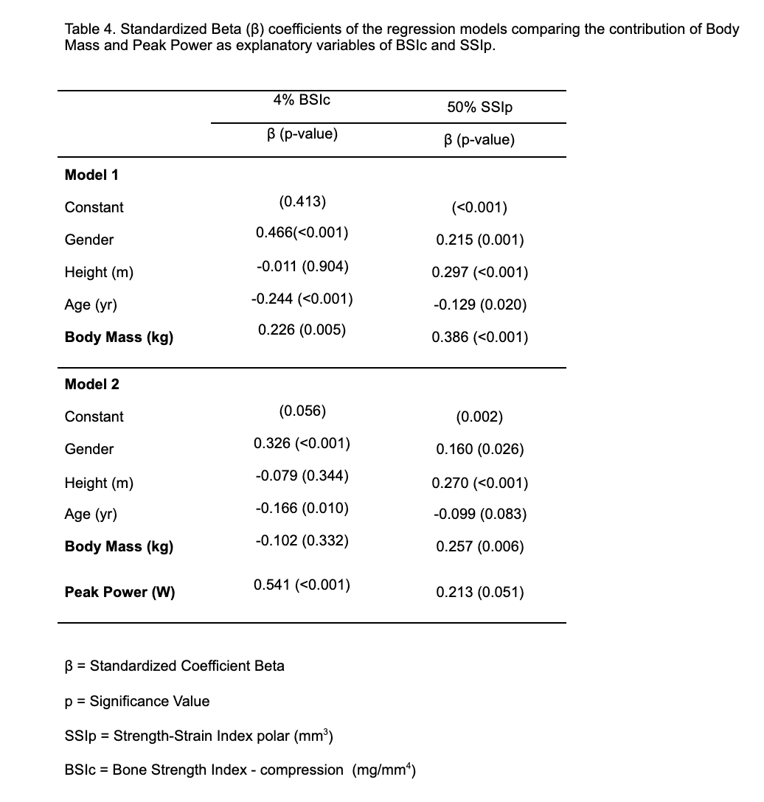

Discussion

The hypothesis was partially supported based on the current data; body mass, a measure of weight bearing load magnitude on the skeletal system, was not an independent predictor of bone strength when a neuromuscular field test, lower limb peak power, was added to a model including sex, height and age. Peak power was linked to a significantly higher amount of variance in the model for trabecular bone strength and was similar to body mass for cortical bone strength. Rantalainen et al. also reported that body mass was not an independent predictor of bone strength for both trabecular bone (BSIc) and cortical bone (SSIp) when concentric next impulse from a neuromuscular test was included in the predictive regression model ³. While body mass was a significant predictor of both cortical and trabecular bone strength, the neuromuscular test which includes body mass, but requires neuromuscular coordination to complete the jump task, was a better predictor and supersedes other predictor variables in the model including sex, height and age. A neuromuscular task may provide an easy to use, cost effective and accessible test for bone health assessment and monitoring.

Bone strength adapts in response to loading by muscular and ground reaction forces; higher loading results in higher bone strength, specifically architectural adaptations ¹. Although body mass affects the magnitude of loading imposed from ground reaction forces, muscle-generated loads on bone are known to exceed impact loading from ground reaction forces due to muscles’ mechanical disadvantage in the human body. Muscle cross-sectional area (MCSA) is often used as a surrogate for actual muscle force acting on bone. Frank et al. ²⁷ found MCSA to be a better predictor variable in models of both tibial BSIc and SSIp compared to body mass. MCSA also predicted bone strength similar to or better than muscle power in recent studies ^{17,28}. However, MCSA does not account for other factors contributing to the magnitude of muscle force and joint torque production, such as fiber type, pennation angle, and moment arm length. In addition, MCSA measures are not easily obtained outside of a clinical or laboratory setting, and therefore create an additional barrier for monitoring bone health in the general population.

The emergence of neuromuscular testing, such as muscle strength and power measures, as a predictor of radial and tibial bone strength demonstrates the potential for a simple screening tool for bone health throughout the lifespan ^{3,17,18,26,29,30}. Neuromuscular power calculated from a vertical jump test, using the Sayer’s equation, demonstrated that it was a strong determinant of bone strength variables among youth and young adult populations ^{17,18,30} and collegiate athletes ²⁹. In a laboratory setting, peak power measurements from knee extension using air-pressure resistance equipment ²⁹ and vertical jump testing on a force plate ³ were found to be independent predictors of bone strength in women (young and post menopausal). The current findings support previous investigations supporting the effectiveness of neuromuscular power measures as a predictor variable for bone strength.

Causation should not be inferred between peak power and bone strength due to the cross-sectional design of the study. Although peak power measurements were a significant predictor of both cortical and trabecular bone strength in models with body mass, it may not be the best neuromuscular performance variable to use for bone-related prediction models. Rantalainen et. al. ³ measured both power and impulse measurements via force plate. The two measurements were significantly correlated to each other, however, impulse demonstrated 5 to 26% stronger correlations than power. Future research should investigate the differences between impulse and power equations on their predictive capacity for bone strength indices. A strength of this study was the large and ethnically-diverse convenience sample. The use of the pQCT to assess bone strength indices for both trabecular and cortical regions of interest is another strength of the study. Unlike DXA, the pQCT quantifies both architectural and material properties of bone. The parameter, strength-strain index (SSIp), an output from a pQCT analysis, provides an approximation for bone strength in vivo ³¹ and was a good estimate of mechanical strength ex vivo ³².

In conclusion, peak power calculated from a vertical jump field test is a significant contributor to the explained variance for bone strength in both trabecular and cortical bone.Compared to body mass, peak power was a better predictor for trabecular bone strength and was similar for cortical bone strength. These data provide additional support for the development of a vertical jump test as a simple, objective, valid and reliable measure to monitor bone strength among youth and adult populations.

Acknowledgements:

We thank the Kinesiology Research Group (KRG) and the Cal State East Bay Athletic Department.
Funding Information
Support provided by the Cal State East Bay Center for Student Research Scholar’s Program.

Contributed to conception and design: VRY, ATD

Contributed to acquisition of data: VRY, ATD

Contributed to the analysis and interpretation of data: VRY, ATD, JCB, CCJ, EJM, KEC, SMW

Drafted and/or revised the article: VRY, ATD, JCB, CCJ, EJM, KEC, SMW

Approved the submitted version for publication: VRY, ATD, JCB, CCJ, EJM, KEC, SMW

References:

1. Novotny SA, Warren GL, Hamrick MW. Aging and the Muscle-Bone Relationship. Physiology. 2015;30(1):8-16. doi:10.1152/physiol.00033.2014
2. Runge M, Rittweger J, Russo CR, Schiessl H, Felsenberg D. Is muscle power output a key factor in the age-related decline in physical performance? A comparison of muscle cross section, chair-rising test and jumping power. Clin Physiol Funct Imaging. 2004;24(6):335-340. doi:10.1111/j.1475-097X.2004.00567.x
3. Rantalainen T, Nikander R, Heinonen A, et al. Neuromuscular performance and body mass as indices of bone loading in premenopausal and postmenopausal women. Bone. 2010;46(4):964-969. doi:10.1016/j.bone.2010.01.002
4. Johnell O, Kanis JA. An estimate of the worldwide prevalence and disability associated with osteoporotic fractures. Osteoporos Int. 2006;17(12):1726-1733. doi:10.1007/s00198-006-0172-4
5. von Friesendorff M, McGuigan FE, Wizert A, et al. Hip fracture, mortality risk, and cause of death over two decades. Osteoporos Int. 2016;27(10):2945-2953. doi:10.1007/s00198-016-3616-5
6. Guzon-Illescas O, Perez Fernandez E, Crespí Villarias N, et al. Mortality after osteoporotic hip fracture: incidence, trends, and associated factors. J Orthop Surg. 2019;14(1):203. doi:10.1186/s13018-019-1226-6
7. Cheung C-L, Lam KSL, Cheung BMY. Evaluation of Cutpoints for Low Lean Mass and Slow Gait Speed in Predicting Death in the National Health and Nutrition Examination Survey 1999–2004. J Gerontol A Biol Sci Med Sci. 2016;71(1):90-95. doi:10.1093/gerona/glv112
8. Bischoff-Ferrari HA, Orav JE, Kanis JA, et al. Comparative performance of current definitions of sarcopenia against the prospective incidence of falls among community-dwelling seniors age 65 and older. Osteoporos Int. 2015;26(12):2793-2802. doi:10.1007/s00198-015-3194-y
9. United Nations (2017) World Population Prospects: 2017 Revision, Department of Economic and Social Affairs, New York.
10. Frost HM. Bone’s mechanostat: A 2003 update. Anat Rec. 2003;275A(2):1081-1101. doi:10.1002/ar.a.10119
11. Haapasalo H, Kontulainen S, Sievänen H, Kannus P, Järvinen M, Vuori I. Exercise-induced bone gain is due to enlargement in bone size without a change in volumetric bone density: a peripheral quantitative computed tomography study of the upper arms of male tennis players. Bone. 2000;27(3):351-357. doi:10.1016/S8756-3282(00)00331-8
12. Kontulainen S, Sievänen H, Kannus P, Pasanen M, Vuori I. Effect of Long-Term Impact-Loading on Mass, Size, and Estimated Strength of Humerus and Radius of Female Racquet-Sports Players: A Peripheral Quantitative Computed Tomography Study Between Young and Old Starters and Controls. J Bone Miner Res. 2003;18(2):352-359. doi:10.1359/jbmr.2003.18.2.352
13. Hind K, Hayes L, Basterfield L, Pearce MS, Birrell F. Objectively-measured sedentary time, habitual physical activity and bone strength in adults aged 62 years: the Newcastle Thousand Families Study. J Public Health. 2020;42(2):325-332. doi:10.1093/pubmed/fdz029
14. Gabel L, Macdonald HM, Nettlefold L, McKay HA. Physical Activity, Sedentary Time, and Bone Strength From Childhood to Early Adulthood: A Mixed Longitudinal HR-pQCT study. J Bone Miner Res. 2017;32(7):1525-1536. doi:https://doi.org/10.1002/jbmr.3115
15. Warden SJ, Mantila Roosa SM, Kersh ME, et al. Physical activity when young provides lifelong benefits to cortical bone size and strength in men. Proc Natl Acad Sci. 2014;111(14):5337-5342. doi:10.1073/pnas.1321605111
16. Beck TJ, Petit MA, Wu G, LeBoff MS, Cauley JA, Chen Z. Does Obesity Really Make the Femur Stronger? BMD, Geometry, and Fracture Incidence in the Women’s Health Initiative-Observational Study. J Bone Miner Res. 2009;24(8):1369-1379. doi:10.1359/jbmr.090307
17. Janz KF, Letuchy EM, Burns TL, Francis SL, Levy SM. Muscle Power Predicts Adolescent Bone Strength: Iowa Bone Development Study. Med Sci Sports Exerc. 2015;47(10):2201-2206. doi:10.1249/MSS.0000000000000648
18. Baptista F, Mil-Homens P, Carita A, Janz K, Sardinha L. Peak Vertical Jump Power as a Marker of Bone Health in Children. Int J Sports Med. 2016;37(08):653-658. doi:10.1055/s-0042-105290
19. Higgins S, Sokolowski CM, Vishwanathan M, et al. Predicting Diaphyseal Cortical Bone Status Using Measures of Muscle Force Capacity: Med Sci Sports Exerc. 2018;50(7):1433-1441. doi:10.1249/MSS.0000000000001581
20. Yingling V, Reichert R, Denys A, et al. Peak vertical jump power predicts radial bone strength better than hand grip strength in healthy individuals. Commun Kinesiol. 2021;1(2). doi:10.51224/cik.v1i2.13
21. Kontulainen SA, Johnston JD, Liu D, Leung C, Oxland TR, McKay HA. Strength indices from pQCT imaging predict up to 85% of variance in bone failure properties at tibial epiphysis and diaphysis. J Musculoskelet Neuronal Interact. 2008;8(4):401-409.
22. Cointry G, Ferretti JL, Reina PS, Nocciolono LM, Rittweger J, Capozza RF. The pQCT “Bone Strength Indices”(BSIs, SSI). Relative mechanical impact and diagnostic value of the indicators of bone tissue and design quality employed in their calculation in healthy men and pre-and post-menopausal women. J Musculoskelet Neuronal Interact. 2014;14(1):29-40.
23. Glüer C-C, Blake G, Lu Y, Blunt1 BA, Jergas1 M, Genant1 HK. Accurate assessment of precision errors: How to measure the reproducibility of bone densitometry techniques. Osteoporos Int. 1995;5(4):262-270. doi:10.1007/BF01774016
24. Sayers SP, Harackiewicz DV, Harman EA, Frykman PN, Rosenstein MT. Cross-validation of three jump power equations. Med Sci Sports Exerc. 1999;31(4):572-577.
25. Faul F, Erdfelder E, Lang A-G, Buchner A. G*Power 3: A flexible statistical power analysis program for the social, behavioral, and biomedical sciences. Behav Res Methods. 2007;39(2):175-191. doi:10.3758/BF03193146
26. Yingling VR, Webb S, Inouye C, O J, Sherwood JJ. Muscle power predicts bone strength in Division II athletes. J Strength Cond Res. Published online August 29, 2017. doi:10.1519/JSC.0000000000002222
27. Frank AW, Labas MC, Johnston JD, Kontulainen SA. Site-Specific Variance in Radius and Tibia Bone Strength as Determined by Muscle Size and Body Mass. Physiother Can. 2012;64(3):292-301. doi:10.3138/ptc.2010-40BH
28. Binkley TL, Specker BL. Muscle-bone relationships in the lower leg of healthy pre-pubertal females and males. :5.
29. Ashe MC, Liu-Ambrose TYL, Cooper DML, Khan KM, McKay HA. Muscle power is related to tibial bone strength in older women. Osteoporos Int. 2008;19(12):1725-1732. doi:10.1007/s00198-008-0655-6
30. King MM. The vertical jump test as a health promotion screening tool for predicting bone strength in young adults. Published online May 1, 2016. doi:10.17077/etd.py5a63vq
31. Ferretti JL, Cointry GR, Capozza RF, Capiglioni R, Chiappe MA. Analysis of biomechanical effects on bone and on the muscle-bone interactions in small animal models. J Musculoskelet Neuronal Interact. 2001;1(3):263-274.
32. Augat P, Iida H, Jiang Y, Diao E, Genant HK. Distal radius fractures: mechanisms of injury and strength prediction by bone mineral assessment. J Orthop Res Off Publ Orthop Res Soc. 1998;16(5):629-635. doi:10.1002/jor.1100160517

